3 Telecommunication Unit Association Inc.
Order Form

Name:
Postal Address:

Email:
Mobile:

ITEM |  | $ | QTY | TOTAL
3TU Cap |   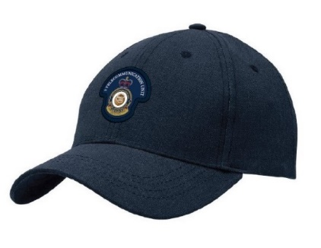 | $30.00ea
Postage | 1-2 Caps  3-5 Caps | $12.00  $16.00

Please email order form to: stanton@wn.com.au

Payments made to:
3TU Association
BSB: 066-163
ACC: 1082 8706

