3 Telecommunication Unit Association Inc.
Order Form

Name:
Postal Address:

Email:
Mobile:

ITEM |  | $ | QTY | TOTAL
3TU Cap | 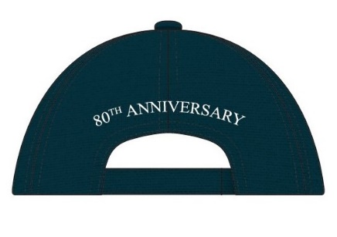  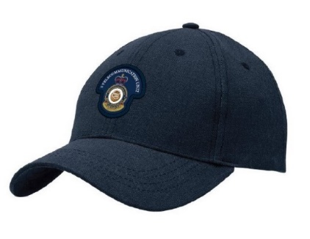 | $30.00ea
3TU Tie |  | $22.00ea
3TU Silk/Poly Scarf | 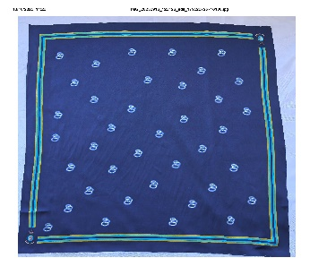 | $37.00ea
Postage* | 1-2 Caps  3-5 Caps  Scarf and/or Tie  *Note: if purchasing a scarf and/or tie with cap/s, the Caps postage only applies. | $12.00  $16.00  $10.00

Please email order form to: 3TU.Association.Treasurer@gmail.com

Payments made to:
3TU Association
BSB: 066-163
ACC: 1082 8706

