3 Telecommunication Unit Association Inc.
Order Form.

Name:
Postal Address
Email:
Mobile:

ITEM |  | $ | QTY | TOTAL
TIE |  | $22.00ea
SILK/POLY SCARF | 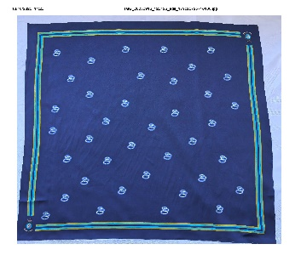 | $37.00ea
POSTAGE |  | $10.00

Please email order form to: 3tuassociation@gmail.com

Payments made to:

3TU Association
BSB: 066-163
ACC: 1082 8706

